



**SREE SAKTHI ENGINEERING COLLEGE**

**Naan Mudhalvan**Project Report   
on  
  
(Phase 5)

**“Noise Pollution Monitoring”**

Submitted in partial fulfillment of the requirement of the Semester V Subject of

**“Internet of Things"**

in

**Electronics and communication Engineering**

By

**RAJARAJAN R (713621106334)**

Project Mentor

**Ass.Prof. E.ELAKKIYA**

**OBJECTIVE;**Design and implement an IoT-based noise pollution monitoring system to continuously collect, process, and visualize noise data in real-time, while also providing alerts and insights to mitigate noise pollution's adverse effects on public health and the environment.

This overarching objective encompasses the core components and goals of this project, which include hardware setup, data collection, transmission, processing, visualization, alerting, compliance, and impact assessment.

**IOT SENSOR DEPLOYMENT;**

Deploying IoT sensors for noise pollution monitoring is a critical aspect of this project. The choice and placement of sensors will significantly impact the accuracy and effectiveness of data collection. Here's a deployment plan for IoT noise sensors:

**Sensor Selection:**

* Choose appropriate noise sensors or microphones capable of capturing a wide range of frequencies and sound levels.
* Ensure that the sensors have the necessary sensitivity and precision for accurate noise level measurement.

**Strategic Location:**

* Identify key monitoring locations based on factors such as noise pollution sources, population density, and environmental sensitivity.
* Place sensors in areas where noise pollution is a concern, including urban centres, industrial zones, transportation hubs, and residential neighbourhoods.

**Calibration:**

* Calibrate sensors regularly to maintain accuracy.
* Use professional calibration equipment and follow manufacturer guidelines.

**Weather Protection:**

* Provide weatherproof enclosures to protect sensors from environmental factors, such as rain, snow, and extreme temperatures.
* Ensure the enclosures do not interfere with the sensors' ability to detect sound.

**Data Transmission:**

* Select the appropriate communication technology (e.g., Wi-Fi, LoRa, cellular) to transmit data to a central server.
* Ensure reliable connectivity for data transfer.

**Data Synchronization:**

* Synchronize the sensors to record data simultaneously for accurate correlation and analysis.
* Use a common time reference, such as GPS time, for synchronization.

**Redundancy:**

* Implement redundancy by deploying multiple sensors at each monitoring location to ensure data integrity.
* Redundant sensors can serve as backups in case of sensor failure.

**Remote Monitoring and Management:** - Enable remote monitoring and management of sensors to check their status, receive alerts, and perform updates without physical intervention.

**Security:** - Implement security measures to protect the sensors from tampering or unauthorized access.

**Documentation:** - Maintain detailed documentation for each deployed sensor, including installation dates, calibration logs, and maintenance records.

**MOBILE APP DEVELOPMENT, AND CODE IMPLEMENTATION;**

Developing a application for noise pollution monitoring using IoT requires multiple components, including sensor integration, data visualization, and alerting. Creating such an application is a complex and multifaceted task, and providing a complete working code in a single response isn't feasible. However, I can provide a web-based application that can display real-time noise data from an IoT sensor.

I uploaded my coding in *Github* by using Python and the Flask web framework for the web application.

**Flask web framework**

<https://github.com/iamrajarajanr/Noise-pollution-monitoring-system/blob/1e6e93ec3b3499b63765e8b8856b0a0fd97715eb/IOT_Phase5/Flask%20web%20framework.py>

**Index(html)**<https://github.com/iamrajarajanr/Noise-pollution-monitoring-system/blob/1e6e93ec3b3499b63765e8b8856b0a0fd97715eb/IOT_Phase5/index.html>

**WORKING DIAGRAM;**

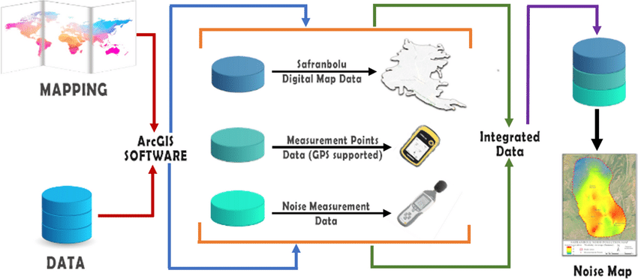

System uses noise sensors to sense presence of noise in the area and constantly transmit this data to microcontroller. Also system keeps measuring sound level and reports it to the online server over IOT. The sensors interact with microcontroller which processes this data and transmits it over internet. This allows authorities to monitor air pollution in different areas and take action against it. Also authorities can keep a watch on the noise pollution near schools, hospitals and no honking areas, and if system detects noise issues it alerts authorities so they can take measures to control the issue.

**BLOCK DIAGRAM;**

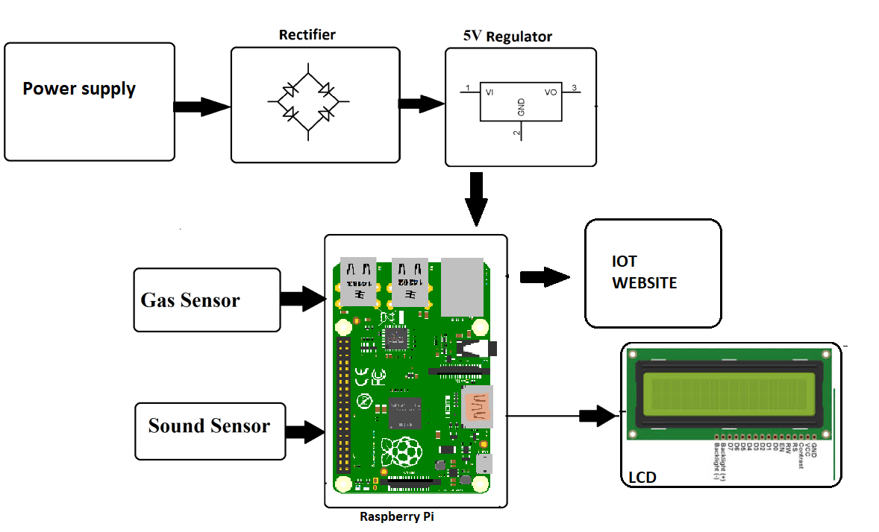

**PICTURE OF THE IOT SENSOR;**

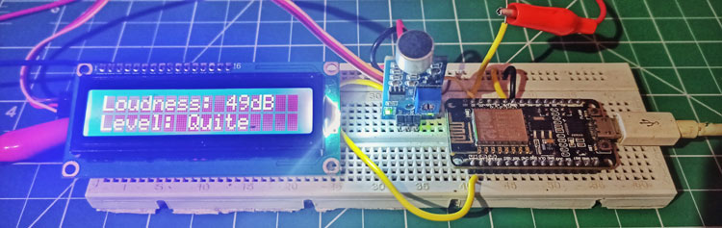

**LOCAL WEB INTERFACES;**

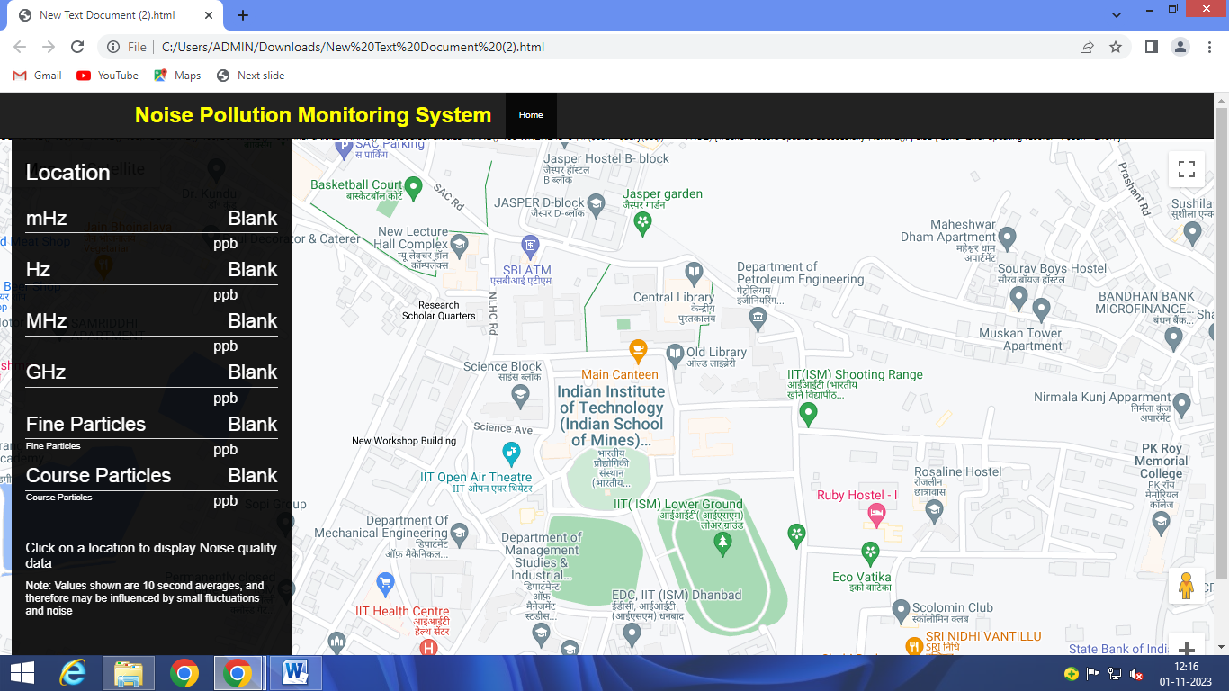

Web developed by using the html,css,php

**CONCLUSION;**

Environmental noise monitoring, driven by sound level meters, is an essential practice for preserving the well-being of individuals and communities. By accurately measuring noise levels, identifying sources, and providing data for regulatory compliance, [sound level meters](https://www.arabcal.com/optical-fibre-test-lab%5d) play a significant role in addressing the challenges posed by noise pollution. This technology not only helps in noise reduction but also promotes healthier and more liveable environments for all.